Atharva Yadav

Roll No : 127 Batch : S23

Network Lab

Assignment No. 2 Install and configure the NS2.

Aim:Install and configure the NS2 and write a TCL script to display welcome message

Output: 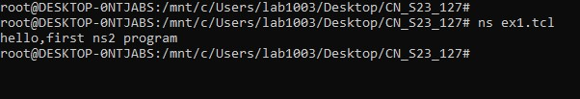

Conclusions: The network assignment on NS-2 equips us with a powerful tool for simulating network behavior.We likely grasped optimizing network protocols and configurations without the risks associated with real-world deployments. scenarios in a controlled environment. This newfound skill is invaluable for designing, troubleshooting, and the fundamentals of working with NS-2, a network simulator that allows you to model and test various network

LO: BASED ON LO1 & LO2